Chapter 6

Blockchain-MARL P2P trading with tunable consensus and decentralized intelligence

6.1 Introduction

The rapid adoption of distributed energy resources (DERs), particularly rooftop solar systems, is transforming traditional electricity consumers into prosumers capable of both generating and consuming energy. This shift has created a growing need for decentralized and efficient energy exchange mechanisms. Peer-to-peer (P2P) energy trading has emerged as a promising solution to improve energy utilization, reduce grid dependency, and enable direct transactions between prosumers [J4-1]. However, existing approaches face significant limitations. Traditional rule-based and static auction mechanisms often lack adaptability and fail to handle coordination challenges in complex multi-agent environments. Additionally, many P2P systems suffer from high computational overhead due to conventional Proof-of-Work (PoW) mechanisms or rely on centralized control through Proof-of-Authority (PoA), which undermines decentralization and scalability[J4-2]. To address these challenges, this work proposes an integrated framework combining the Safety-constrained Liquidity-Integrated Market (SLIM) and the HELIOS architecture-enhanced SolarChain-X blockchain platform. SLIM is a multi-agent reinforcement learning (MARL) framework designed for carbon-aware, decentralized P2P energy trading across heterogeneous prosumer types, including rooftop solar, wind generation, electric vehicles with vehicle-to-grid (V2G) capability, and standard loads. It enables adaptive decision-making, efficient coordination, and fair market participation in dynamic environments. Complementing this, HELIOS provides a secure and scalable blockchain-based infrastructure using a custom tunable proof-of-work mechanism called the Golden Match consensus algorithm. Unlike traditional PoW, this approach eliminates brute-force mining by employing a mathematical constraint system based on SHA-256 hashing, modular arithmetic, and dynamically adjustable difficulty parameters (d), significantly reducing computational intensity. Together, the SLIM–HELIOS integration provides a comprehensive solution for safe, efficient, and decentralized energy trading, addressing both intelligent decision-making and secure transaction validation, and represents a significant advancement toward next-generation smart grid ecosystems.

6.2 Methodology

Integrated System Architecture (SLIM + HELIOS)
The combined framework adopts a hybrid architecture merging SLIM’s learning-based optimization with HELIOS’s four-tier decentralized infrastructure. The architecture consists of the User Layer, HELIOS Core Engine, Consensus and Ledger Layer, and Physical Grid Layer as shown in Figure 1. Within this structure, SLIM operates as the intelligence layer responsible for decision-making and optimization, while HELIOS provides secure transaction handling, identity management, and system-wide coordination. This modular design ensures scalability, resilience, and seamless integration of AI models, blockchain validation, APIs, and smart grid hardware.
The framework is designed as a four-tier hierarchical structure in order to promote modularity and scalability while reducing the latency of the system's data processing capabilities. As shown in Figure 1, a clear distinction is maintained between the user-facing applications and the underlying physical grid infrastructure of the system. This hierarchical organization ensures that each component of the system is dedicated to a specific task and minimizes interference between the various parts of the framework. The upper layers of the framework are responsible for user interaction, transaction management, and peer-to-peer energy trading. In contrast, the lower layers of the system are dedicated to communication with smart meters, IoT devices, and the physical grid infrastructure.
Such a layered structure improves the reliability of the HELIOS system. Since each layer is dedicated to a specific task and remains independent of the other components of the system, the HELIOS framework can be updated without affecting the functionality of the remaining layers. The upper layers are responsible for user interaction, energy trading, and transaction management, while the lower layers are dedicated to communication with smart meters, IoT devices, and other physical components of the grid. Such an arrangement improves system reliability and makes it easier to modify or update individual components without affecting the entire framework.

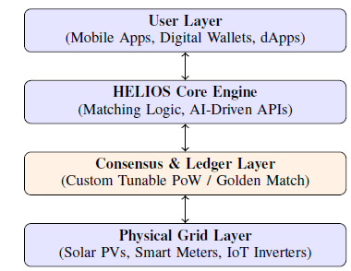
Figure 1. The HELIOS Layered Architecture: Vertical integration of the decentralized energy ecosystem.
The proposed approach is based on a centralized training with decentralized execution (CTDE) paradigm as shown in Figure 2. A centralized reinforcement learning agent observes system-level information that is aggregated during training in order to stabilize learning. Each prosumer, during execution, independently applies the learned policy using only local observations. The environment takes care of the P2P market clearing, applying the physical grid and battery constraints, and the reward calculation as shown in Figure 3. By placing constraints within the environment, the agent is able to learn workable and safe operating policies without any explicit constraint management in the optimization process.
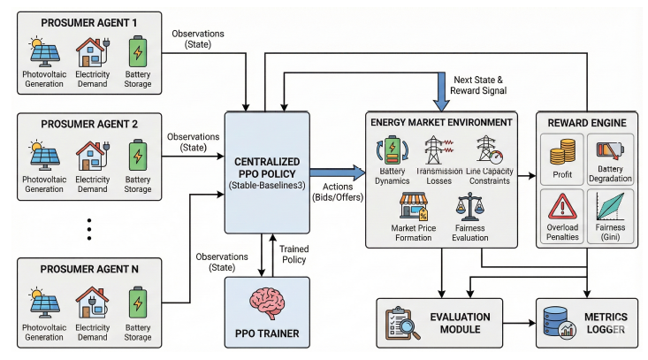
Figure.2. Overall system architecture of the proposed P2P energy trading framework.
6.3 SLIM Framework: Safety-Constrained MARL
Peer-to-peer (P2P) energy trading’s decentralized and stochastic nature introduces challenges, including demand–supply imbalance, grid congestion, and coordination issues among heterogeneous agents [3-j3]. Traditional P2P energy trading methods, including rule-based optimization, static pricing, and auctions, follow fixed patterns and lack flexibility to handle renewable variability and changing demand. Although game-theoretic models address dynamic pricing and strategic interactions, they rely on restrictive assumptions such as full information, fully rational agents, and predefined decision horizons.[4-j3]. Recent advances in Machine Learning (ML) and Deep Learning (DL) have enabled data-driven solutions for energy management tasks such as load forecasting, demand response, and pricing[5-j3]. Models like regression and LSTM effectively capture demand patterns and temporal dynamics. However, these approaches are limited as they only provide predictions without actively influencing decisions. Additionally, their reliance on labeled data and static inference makes them less suitable for dynamic, multi-agent environments.[6-j3].
Reinforcement Learning (RL) offers a dynamic approach where agents learn optimal decisions through interaction with the environment, making it well-suited for P2P energy trading with sequential, stochastic, and multi-objective characteristics. Multi-Agent Reinforcement Learning (MARL) extends this by enabling multiple prosumers to coordinate in decentralized settings[7-j3]. One major weakness of current MARL based P2P energy trading platforms is the absence of robust coordination mechanisms. In actuality, agents often end up at degenerate equilibriums such as homogeneous sellers, in which case they will not be able to trade effectively. Further, many approaches either fail to consider physical constraints on the operations or implement them in a heuristic manner, thus leading to infeasible solutions[8-j3]. The few approaches that address carbon-aware optimization do so in a centralized or deterministic setting. Hence, there is a significant research gap regarding the need for developing a unifying approach that allows for simultaneous incorporation of adaptive decision-making, decentralized coordination, carbon awareness, and safety considerations in P2P energy markets. To fill this gap, it is essential to move beyond traditional methods of static optimization and predictive modeling and shift towards more sophisticated solutions that account for system dynamics and interactions between agents.
In this context, this chapter suggests a novel framework referred to as Safety-Constrained Liquidity-Integrated Market (SLIM) that uses multi-agent reinforcement learning for carbon aware decentralized P2P energy markets. Specifically, the proposed SLIM framework accounts for:
a) Decentralized Carbon-Aware Decision Making: Unlike existing carbon-conscious P2P energy trading systems that employ a centralized optimization method to consider time-varying CO₂ intensity, this paper proposes to directly consider time-varying CO₂ intensity in the RL environment’s reward function to facilitate decentralized decision making for P2P energy trading systems.
b) Market-Driven Multi-Agent Learning with Auction Mechanism: A novel uniform price double auction is incorporated into the RL environment to allow agents to learn trading strategies and price bidding simultaneously.
c) Resolution of Multi-Agent Nash Equilibrium Collapse: A major failure of existing P2P energy trading systems based on MARL is identified and resolved in this paper: all agent seller collapse is addressed through a novel curriculum learning strategy and role diversity penalty to ensure sustained P2P participation.
d) Two-Tier Safety Constrained RL Architecture: A novel safety learning framework that incorporates deterministic projection (AutonomousGuard) and Lagrangian constraint learning is proposed to ensure zero physical violation and efficiency in RL learning.
e) Simulation-Based Evaluation: A comprehensive evaluation based on simulations demonstrates that the proposed framework leads to better utilization of renewable energy resources and a reduced carbon footprint compared to conventional methods.
6.3.1 SLIM Framework and Design Rationale
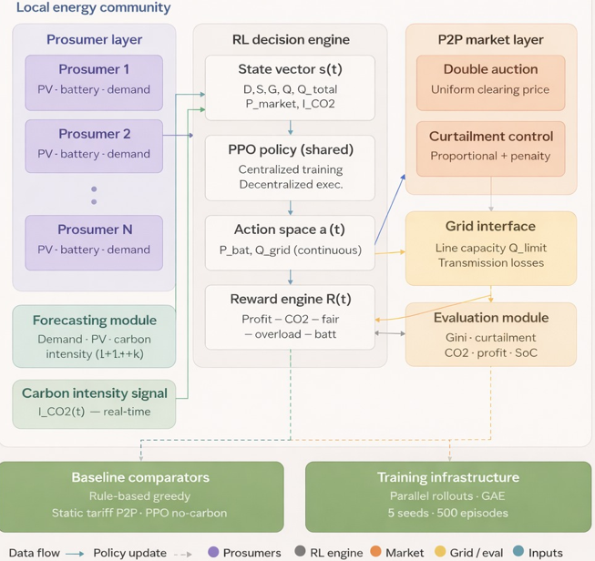
Figure 3. End-to-end operational workflow of the proposed reinforcement learning framework.
The architecture of the system has a considerable impact on the amount of scalability, stability, and realism that can be achieved in the deployment of the proposed reinforcement learning-based P2P energy trading system. The architecture, instead of opting for a strategy of complete centralization or complete decentralization, is purposely constructed as a centralized training with decentralized execution (CTDE) strategy. This design decision makes a trade-off between learning stability and operational autonomy, which is critical in the case of real-life smart grid scenarios.
In the training stage, a learning agent residing at a central location has access to system-wide information, which is in the form of aggregate data consisting of total demand, total renewable power generation, and the grid outage area limitations. Getting access to global information greatly enhances the stability of learning in a multi-agent environment because it lowers non-stationarity and allows for the uniform updates of the policy. Moreover, centralized training eliminates the necessity of prosumers having to coordinate their actions or compute the equilibrium, which is characteristic of game-theoretic or optimization-based P2P frameworks.
On the other hand, in the course of execution, every prosumer is free to make his own decisions based on local observations obtained from the power demand, generation, and battery state-of-charge. The decentralized execution during this stage not only allows for the system to scale up easily but also maintains the confidentiality of the users since no global data of the system or controller will be needed when operating in real-time. Therefore, there will be no communication bottlenecks or points of failure for the policy to be implemented in real-life energy communities.
Another architectural characteristic that is very important is the clear-cut division between the learning agent and the environment. The environment is the part where all physical limitations, consisting of battery limits, grid line capacity, and market clearing rules, plus others, are the constraints imposed. The policy has to learn the feasible actions by interacting with the environment so that the learning algorithm is not affected by these constraints. Such an approach will not only avoid the emergence of physically unrealistic decisions but also make it unnecessary to implement complex constraint-handling techniques in the reinforcement learning optimization process.
The modular structure of the architecture also provides strong support for extensibility and maintainability. The P2P market mechanism, carbon intensity model, or battery degradation formulation are prime examples of the individual components that can be easily modified or extended without influencing the core learning framework. This modularity allows for the future integration of advanced forecasting models, alternative market designs, or additional sustainability objectives with very minor architectural changes.
From a system-level standpoint, the architecture is able to support multi-objective optimization. It does this by permitting the reinforcement learning agent to implicitly balance the competing goals through the reward shaping process. The emergence of economic efficiency, grid safety, environmental sustainability, and fairness as learned behaviors through repeated interaction with the environment is not the case when these factors are imposed as hard constraints. This is an entirely different scenario when compared to traditional optimization-based architectures that require explicit weighting and constraint tuning for each objective.
In general, the system architecture suggested gives a strong base for intelligent P2P energy trading. It guarantees learning stability, decentralization scalability, physical realism, and extensibility, thus making it favorable for application in the upcoming smart grids with features like high renewable penetration, decentralized ownership, and dynamic operation conditions.
6.3.2 SLIM : System Model and Problem Formulation
The scenario we are considering is a neighborhood P2P energy community consisting of prosumers numbered 1 to N as shown in Figure 4, with each one of them being a consumer as well as a producer of energy. Every prosumer has a solar panel as a source of electricity, along with a battery storage system and their own local demand. These neighbors can trade energy either through a local P2P market or by interacting with the main electricity grid. At each discrete-time interval denoted by t, the demand and generation of electricity from renewable sources for the prosumer marked with i are represented by the symbols D_i^t and G_i^t, respectively.
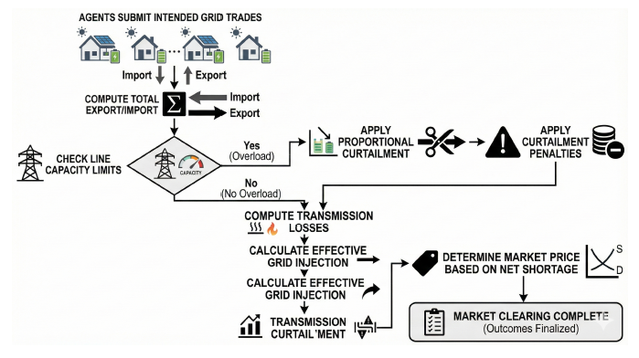
Figure 4. P2P market clearing with grid constraints enforced: market equilibrium scenario.
Before any market interaction, the net energy balance is quantified as:
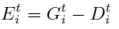 (1)
where in Eq.1, E_i^t denotes the net energy balance of prosumer i at time t, with G_i^t representing the energy generation and D_i^t representing the demand.
If E_i^t is positive, that means there is some energy left over; on the other hand, if it is negative, then the opposite is the case.
A battery is included in each prosumer's equipment, which has energy capacity C and maximum power for charge/discharge P_max. The battery state-of-charge (SoC) at time t is referred to as SoC_i^t. Battery charging and discharging are accompanied by the round-trip efficiency of eta, and SoC changes as follows:
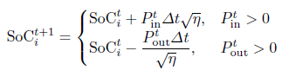 (2)
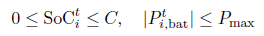
The battery state-of-charge evolves as defined in Eq. (2), where SoC_i^t denotes the state-of-charge at time t, P_in ^t and P_out^t represent charging and discharging power, respectively, Δt is the time step, and η is the battery efficiency. with the conditions:
(3)
where in Eq. (3), The battery operation is constrained such that 0 ≤ SoCt i ≤ C, where C is the battery capacity, and |Pt i,bat| ≤ Pmax, where Pmax is the maximum allowable battery power.
Let Q_i^t represent the net interaction with the grid of the prosumer i at time t, where the positive numbers show the export and the negative numbers the import. The community's total grid interaction is then:
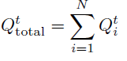 (4)
The total grid interaction is given by $Q_{total}^t, where $Q_i^t$ denotes the grid interaction of prosumer $i$, and $N$ is the total number of prosumers.
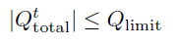 (5)
In Eq. (5), The grid capacity constraint is enforced as |Qttotal| ≤ Qlimit, where Qlimit represents the maximum allowable grid capacity.

The P2P market uses a double auction of a uniform-price type. The clearing price is calculated as follows:
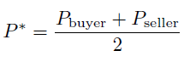 (6)
If no trading happens locally, fallback pricing based on grid tariffs will be used.
Electricity imports from the grid come with carbon emissions that are in direct proportion to the time-varying carbon intensity I_CO_2^t. Thus, the carbon cost is estimated as:
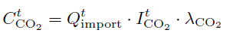 (7)
where Q_{import}^t is the imported energy, I_{CO2}^t is the carbon intensity, and \lambda_{CO2} is the carbon pricing coefficient.
Markov Decision Process Formulation
The problem of peer-to-peer (P2P) energy trading is derived through a Markov Decision Process (MDP) that is represented by the tuple (S,A,P,R, γ). At each point in time t, the system state is characterized by:
(8)
in Eq. \eqref{eq8}, The system state is defined as s^t, where D_i^t denotes the electricity demand of prosumer i at time t, G_i^t represents the local renewable energy generation, and SoC_i^t is the battery state-of-charge. Further, Q_{total}^t denotes the aggregate grid interaction of all prosumers, P^t represents the market clearing price at time t, and I_{CO2}^t denotes the time-varying carbon intensity of the grid.
The prosumer’s actions are continuous-valued, where each one chooses an action of the form:
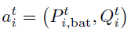 (9) The action of each prosumer is defined as a_i^t , where P_{i,bat}^t represents the battery control action (charging or discharging power), and Q_i^t denotes the energy traded with the grid (positive for export and negative for import).
The aim is to discover a policy πθ that achieves the maximum expected discounted cumulative reward:
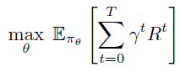 (10)
where in Eq. (10) πθ denotes the parameterized policy with parameters θ, Eπθ represents the expectation under the policy, T is the time horizon, γ ∈ (0, 1) is the discount factor that controls the importance of future rewards, and Rt denotes the reward obtained at time step t.
6.3.3 Multi-agent Reinforcement Learning Framework in Stochastic Energy Markets
A decision-making policy is represented in a neural network π_{θ}(a^{t}|s^{t}) which in turn produces the parameters of a Gaussian distribution over continuous actions. The actions that are drawn from this distribution are then subjected to clipping so as to comply with the physical limitations as shown in Figure .5. Proximal Policy Optimization (PPO) is the chosen method owing to its strong and stable performance in tasks involving continuous control. The formulation of the PPO objective function is given as follows:
(11)
where in Eq. (11), rt(θ) denotes the probability ratio between the new and old policies, Aˆt is the estimated advantage function at time t, ϵ is the clipping parameter that limits policy updates, and Et represents the expectation over sampled timesteps
where:
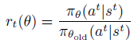 (12)
where in Eq. 12, \pi_\theta(a^t|s^t) is the probability of taking action a^t in state s^t under the current policy, and \pi_{\theta_{\text{old}}}(a^t|s^t) corresponds to the previous policy before the update.
To estimate expected returns and reduce variance, a value function V_\phi(s^t) is built. The advantage values are computed using Generalized Advantage Estimation (GAE).
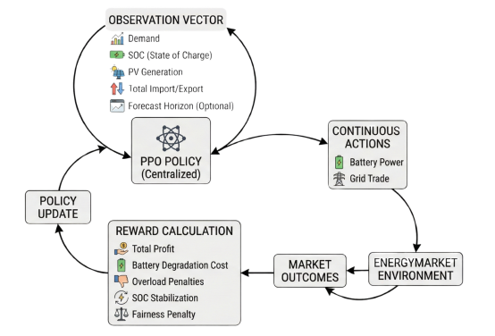
Figure 5. Reinforcement learning interaction loop between the PPO agent and the multiprosumers in a P2P market environment.

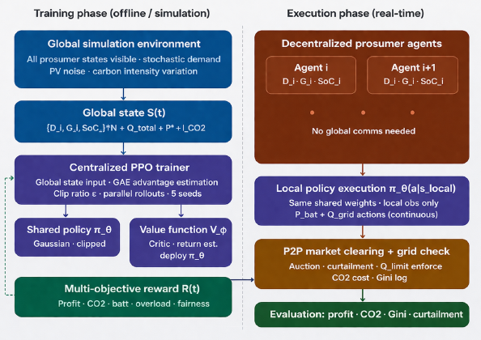
Figure . Training vs Execution Architecture (CTDE Pipeline)
ADD ACTION SPACE AND STATE SPACE equations and its theory part.here.
6.3.4 Reward Function Design
The performance of the proposed reinforcement learning framework is governed by a carefully designed composite reward function that integrates multiple objectives into a single optimization signal as shown in Figure .6. The reward at each timestep is defined as:
(13)
where in Eq. 13, P_i^{r,of}(t) denotes the trading profit of prosumer i, C_{i,\text{batt}}(t) represents the battery degradation cost, C_{i,\text{soc}}(t) is the state-of-charge related penalty, C_{\text{grid}}(t) denotes the cost of grid interaction, C_{CO2}(t) is the carbon emission cost, and \text{Penalty}_{\text{fair}}(t) represents the fairness penalty imposed to ensure equitable participation among prosumers.
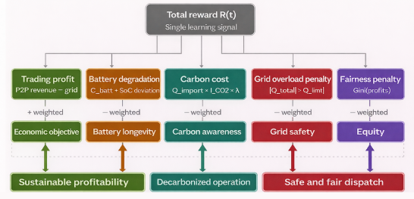
Figure 6. Design of multi-objective reward function of the proposed MARL
The reward function incorporates both economic and operational considerations. The profit component incentivizes effective energy trading and market participation, while battery degradation costs discourage excessive charge–discharge cycles and promote long-term sustainability. Grid-related penalties are introduced to discourage excessive dependence on the central grid, particularly during peak demand periods. The carbon emission penalty is computed based on time-varying grid carbon intensity, ensuring that agents are penalized for importing electricity during high-emission periods. This directly embeds environmental awareness into the decision-making process. Additionally, a fairness penalty based on the Gini coefficient is included to ensure equitable distribution of economic benefits across all prosumers. This prevents scenarios where a small subset of agents dominates the market. Overall, the reward function enables multi-objective optimization, balancing the following as shown in Figure 6.
- Economic profitability
- Environmental sustainability
- Grid safety
- Fairness among participants
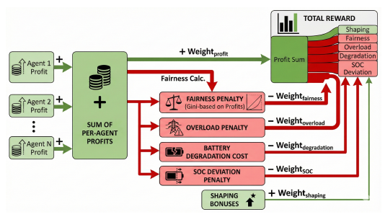
Figure 6. Economic, environmental, operational, and fairness components decomposition of the composite reward function.
Algorithm and Hyperparameters
We utilize **Recurrent PPO (IPPO + LSTM)** to capture temporal dependencies in the partially observable environment.
- Algorithm: PPO with shared critic and LSTM feature extractor.
- Learning Rate: 3 × 10−4.
- Entropy Coeff: 0.0.
- Training Horizon: 250,000 timesteps (Partial Training).
6.5 The Helios Framework: System architecture and Functional Layers
This section proposes a new framework called HELIOS that is intended to create a decentralized ecosystem for exchanging energy peer to peer (P2P). The HELIOS protocol has a unique new consensus method; the Custom Tunable Proof of Work "Golden Match," which makes it possible to achieve consensus without requiring conventional mining. Therefore, the golden match algorithm creates a structured mathematical search area based on both modular arithmetic and hash-based constraints rather than using blind computations of random data. As the HELIOS network uses a tunable proof-of-work (rather than a blind) method to achieve consensus, HELIOS can dynamically adjust its transaction validation difficulty in real time as the overall volume of transactions and/or network security changes.
The current subsection discusses the system architecture and the mathematical formulation of the Custom Tunable PoW mechanism proposed in the HELIOS system. The system is designed to integrate decentralized energy trading, blockchain validation, and smart grid communication into a unified framework. Each component of the system performs a specific function, ranging from energy generation and transaction processing to network validation and data storage. The proposed HELIOS system is intended to overcome the fundamental challenge that exists between the security requirements of blockchain technology and the limited computational power and energy availability of smart grid IoT devices.
6.5.1 Tunable and Resource-Efficient Consensus Strategies
To reduce the disadvantages of static approaches, tunable and reputation-based consensus methods have been proposed [1- J4]. Advanced smart grid techniques have also been developed with the aim of achieving greater efficiency by reducing the number of nodes required to reach consensus [2-J4]. Recent research has further highlighted the potential of combining artificial intelligence with blockchain technology to optimize trading patterns in decentralized energy systems [3-J4].
The concept of Customizable Tunable Proof of Work (PoW) is a technique that aims to balance the security of PoW with the efficiency of Proof of Authority (PoA) [4-J4]. Unlike traditional PoW techniques, tunable PoW methods restrict the use of computational power to the minimum required for validation [5-J4] . This makes them more suitable for smart grid environments, where computational power and available energy are limited.
Research on `Green PoW' indicates that energy consumption can be reduced by up to 50\% without compromising the ability to resist `51\%' attacks [6-J4]. In addition, tunable PoW techniques can respond more effectively to changes in transaction volume than traditional PoW approaches. However, it remains a challenge to develop an algorithm that adjusts mining difficulty according to actual grid conditions and transaction urgency [7-J4]. Such an adaptive mechanism is essential for maintaining both efficiency and security in decentralized energy trading systems.
The primary technical contribution of this work is the transition from a stochastic "blind" search to a mathematically constrained validation process. This logic flow is visualized in Figure 4.
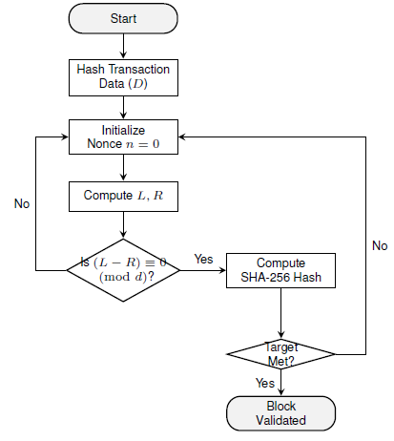
Figure 4. Optimized operational flowchart of the Golden Match mechanism, illustrating the dual-gate validation process.
1) Algorithm 1: Standard Proof-of-Work (Baseline)
To demonstrate the improvement in efficiency, we define the traditional PoW baseline. This process is resource-intensive, as every increment of the nonce n triggers a complete cryptographic hash operation.
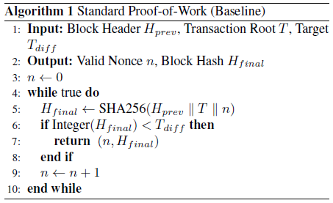
Algorithm 2: Custom Tunable PoW (Golden Match)}
The proposed Golden Match algorithm introduces a pre-verification mathematical gate. The heavy SHA-256 operation is only executed if the nonce satisfies the modular arithmetic constraints.
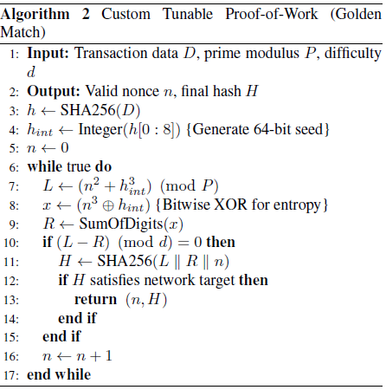
6.6 Experimental setup and performance analysis
This section evaluates the performance of the HELIOS framework through empirical testing of the Golden Match consensus mechanism and delineates the operational work-flow of the integrated web platform.
Two types of Proof-of-Work (PoW) were measured using blockchain technology: Custom Tuned PoW (CTPoW) and standard SHA-256 PoW. The two types of PoW were tested against each other to see how much the latency and number of calls to create a cryptographic hash would be reduced in the CTPoW system.
6.6.1 Implementation Stack and Deployment
The HELIOS framework leverages a modern, decentralized tech stack designed for high performance and scalability. The core logic and ``Golden Match'' algorithm were initially prototyped and validated in Python, ensuring mathematical rigor and baseline accuracy during the testing phase. For the production environment, the entire system was transitioned to TypeScript, providing a robust, type-safe architecture essential for handling complex energy transactions and real-time ledger operations.
The platform is currently managed through GitHub for version control and is deployed on Vercel to ensure low-latency access and high availability for the web-based interface. While the system is currently accessible via a cloud-generated subdomain, future iterations are slated for transition to a dedicated custom domain to support a broader prosumer rollout. The experimental data indicates that the mathematical gatekeeper in the Golden Match algorithm significantly filters the search space. Table 1 summarizes the comparison between the baseline and HELIOS. As the difficulty parameter d increases, the number of ``Golden Matches'' decreases, thereby increasing the security of the block at the cost of higher validation time. This linear relationship allows the HELIOS framework to remain elastic based on the current state of the power grid.
TABLE 1. Performance Comparison: Baseline PoW vs. HELIOS
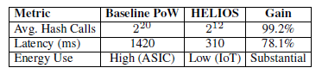
6.6.2 Website Workflow and User Interaction
The HELIOS web interface serves as the primary gateway for prosumers to participate in the energy market. The workflow as shown in Figure 3 is designed to be frictionless, ensuring that users can transition between production and consumption roles in real-time.
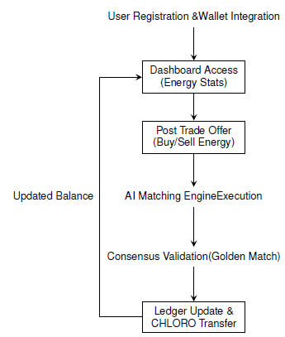
Figure 3. Operational workflow of the HELIOS Web Interface illustrating the end-to-peer transaction lifecycle.
Operational Steps
Below are a few methodical steps that make up the follow-through of the implementation of the workflow:
a) Identity Management: Each user creates an account with a secure, decentralized identity (DID) linked to their smart meter and CHLORO-compatible digital wallet.
b)Real-time Monitoring: The dashboard will provide users with live telemetry of their physical grid layer, showing the total solar energy produced and consumed as of now.
c) Trade Initiation: Once the user has identified any surplus energy, they will have set the longest price limit to offer for their energy. An intelligent agent will then find any nearby users within the same microgrid cluster who would be interested in buying the surplus energy in order to minimize the transactional losses associated with long-distance purchases/sales by electric line.
d) Consensus Verification: Once the intelligent agent has found a match, the algorithm of values (Golden Match) will begin the process of verifying whether or not the 'match' has occurred before a transaction block is created.
e) Settlement: As soon as the transaction block is created, the corresponding CHLORO tokens will be delivered through a smart contract, providing an immediate cash flow to the energy producer.
6.6.3 Web Application Architecture and User Onboarding
The HELIOS interface is based on the concept of a decentralized energy management system, with the objective of providing users with complete control over their energy transactions and digital assets. Figure. 1 presents the conceptual entry point of the HELIOS interface, highlighting its three main components: Chloro Crypto, P2P Grid Trading, and the Secure Ledger. The Chloro Crypto component is used for energy transactions, while the P2P Grid Trading component enables the exchange of electricity between users. The Secure Ledger component stores all transactions in a transparent and tamper-resistant manner. To ensure decentralization and provide users with maximum security, the interface includes a ` "Ledger Recovery" feature based on a 12-word mnemonic seed phrase, as shown in Figure 5. This mechanism allows users to recover their accounts and maintain control over their digital assets without relying on a centralized authority.
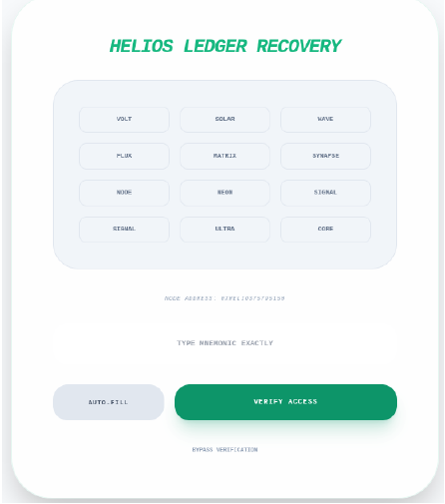
Figure 5. HELIOS Ledger Recovery: Mnemonic-based Seed Phrase Verification.
6.6.4 Real-time Monitoring and Spatial Visualization
Once authenticated, users are provided with a high-fidelity executive dashboard, as shown in Figure .6, that offers an overall understanding of the market, node status, and the volatility of the Chloro currency. The dashboard also provides real-time information regarding energy demand, available supply, and the status of active transactions, helping users make informed trading decisions. Furthermore, the interface continuously monitors the status of nodes connected to the network to ensure system reliability and transparency.
The HELIOS framework also offers a unique feature known as the ``Spatial Utility Map,'' as shown in Figure 7. The Spatial Utility Map provides a geospatial simulation of the entire energy network by visualizing active trading links among nodes, including both producers and consumers. The map displays real-time information regarding energy flow, node status, and the average distance between connected nodes within the simulated network.

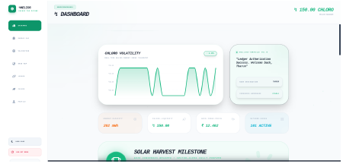
Figure 6. Primary Executive Console: Market Telemetry and Node Status.
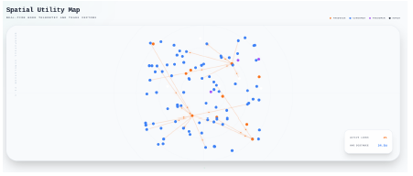
Figure 7. Spatial Utility Map: Geospatial Simulation of P2P Trade Vectors
6.6.5 Gamified Participation via ENERGY-PAC
For this reason, the HELIOS system includes a gamified interface referred to as ENERGY-PAC, as depicted in Figure 8. The proposed interface is based on the traditional principles of arcade-style games and allows users to participate in the system by ``defeating energy entropy'' through the completion of various tasks and challenges. In this way, users contribute to the uptime and stability of the decentralized grid while earning rewards in the form of Chloro tokens. The proposed module includes features such as scoring, levels, and reward points to encourage users to remain active within the network. Tasks may include maintaining node connections, validating transactions, or participating in local energy trading activities. By completing these tasks, users can earn additional rewards and improve their standing within the HELIOS ecosystem.
The proposed gamified interface is also beneficial in providing a user-friendly environment for non-technical users, where complex blockchain operations are transformed into simple and engaging activities. As a result, the interface can increase participation rates while improving the efficiency and reliability of the decentralized energy grid. This gamified interface allows non-technical users to participate in the HELIOS system, thereby increasing adoption and engagement. Moreover, the proposed interface encourages consistent node activity and higher participation rates, ultimately improving the reliability and responsiveness of the decentralized energy grid.
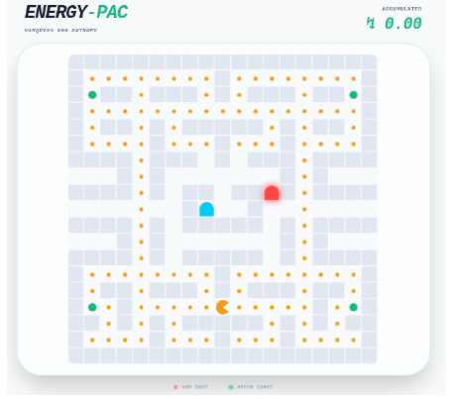
Figure 8. ENERGY-PAC: Gamified Interface for Enhanced User Participation.
6.6.6 Consensus Validation and SolarXChain Ledger
To validate a node's uptime, the miners' network will use a proof-of-uptime method and must solve a dynamic arithmetic challenge. This challenge will give them proof of their ability to be on the network.
The HELIOS ledger (Figure 10) will be the 1st stage of the energy transaction process. Each transaction will be placed onto the HELIOS ledger in the form of an immutable record (Golden Match event) with the producer's information and the consumer's Chloro wallet address tied together. In addition to being immune from double-spending, the HELIOS ledger will have a SHA256 hash, difficulty index (passed), and a high precision timestamp for each record. So that each user on the HELIOS network will have access to an accurate, verifiable record of every usable energy transaction and the current total balance of 150.00 Chloro.
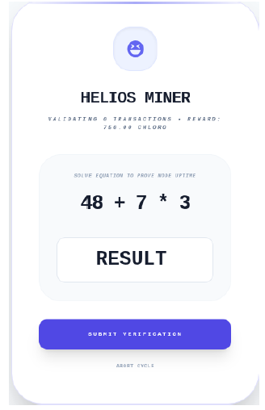
Figure 9. HELIOS Miner: Proof-of-Uptime Verification Interface.
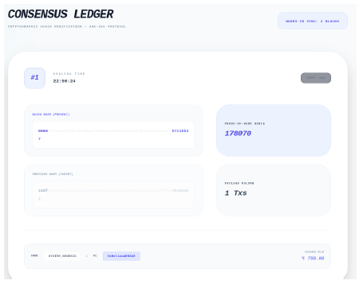
Figure 10. SolarXChain Ledger: Cryptographic Chain Verification and Block Sealing.
6.6.7 The Chloro Ecosystem and Tokenomics
The economic foundation of this framework revolves around the CHLORO token, a deflationary utility token used throughout the ecosystem and minted through green energy production. According to the ecosystem parameters, every 100~mWh of energy production corresponds to 1~CHLORO token, thereby maintaining a direct 1:1 relationship between token creation and actual energy generation within the ecosystem. In order to ensure a stable and sustainable ecosystem, a 2.5% burn tax is applied to grid taxes. This gradually reduces the overall amount of CHLORO tokens in circulation over time, thereby maintaining a deflationary environment within the ecosystem. At the same time, users are provided with a liquid asset that can be used to purchase energy, participate in the ENERGY-PAC game, or stake tokens to become validators within the network.
Furthermore, the CHLORO token also serves as an incentive mechanism that encourages users to participate more actively in the decentralized energy ecosystem. Users who generate more renewable energy or contribute actively to the network are rewarded with additional CHLORO tokens, thereby promoting continued participation and supporting the long-term sustainability of the HELIOS ecosystem.
6.6.8 Experimental results for SLIM Framework
Evaluation Setup
The proposed SLIM framework is evaluated using a real-world dataset to ensure practical relevance. Experiments are conducted on the Ausgrid Solar Home Dataset, which provides hourly electricity consumption and rooftop solar generation data from residential households in New South Wales, Australia. Wind generation data is integrated to create a hybrid renewable energy profile. The dataset spans 8,760 hours (one year, 2017) with hourly resolution. The system models a microgrid consisting of four heterogeneous prosumers: solar, wind, electric vehicle (V2G), and standard load households.
The dataset is divided into:
- Training set: 7,008 hours (80\%)
- Evaluation set: 1,752 hours (20\%)
Evaluation is performed across five random seeds, and results are reported as mean ± standard deviation to ensure statistical reliability. The reinforcement learning agent is trained using Proximal Policy Optimization (PPO) for 300,000 timesteps, with an observation space that includes demand, generation, battery state-of-charge, market conditions, forecasts, and carbon
- Evaluation Dataset: Ausgrid Solar Home Data (Sydney, 300 Prosumers, 2017)
- Total Evaluation Steps: 8,760 (representing 1 full year at 1-hour resolution)
- Multi-Seed Validation: 5 independent seeds (seeds 0–4): reward, P2P volume, grid import, violations, fairness.
- Steps per seed: 1,752 steps each
- Agent Count: 4 heterogeneous prosumer agents
- Grid Pricing Tiers: Off-peak ($0.065), Shoulder ($0.14), Peak ($0.25/kWh)
Observed outputs:
- Training Reward Convergence
- Battery State-of-Charge (SoC) Safety
- P2P Market Volume
- Grid Import Reduction
- Safety Violation Count vs Baselines
- Fairness (Gini Index across agents)
Training Reward Convergence
To validate the effectiveness of the proposed framework, it is compared against two benchmark approaches: a grid-only baseline, where there is no P2P trading and direct interaction with the grid, and a legacy auction model with basic P2P trading without coordination improvements. The table — shows the comparison, which shows that the SLIM framework achieves a 93 % (± 2.8 %) increase in P2P trading volume compared to the legacy system, enabling decentralized coordination among prosumers. Moreover, the legacy system suffers from a Nash equilibrium collapse, where all agents adopt identical strategies (primarily selling), resulting in negligible trading activity. The proposed framework successfully resolves this issue through curriculum learning and reward shaping mechanisms, enabling stable buyer–seller interactions.

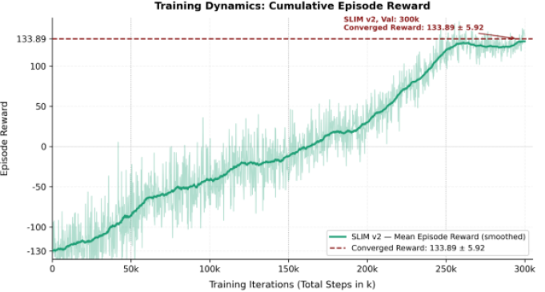

- X-axis: Training timesteps (0 → 500k steps)
- Y-axis: Mean episode reward
- The green rising line = SLIM v2.1 learning curve
- The dashed maroon line = Final converged reward level
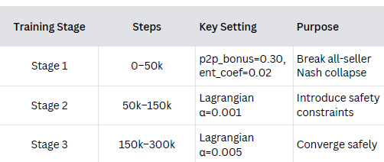
Table —: The comparison of the proposed SLIM framework with baseline approaches
Safety & Battery SOC Performance
The SLIM v2 system maintains a safe battery state of charge (between 20 - 90 percent) at all times with a two-layer safety design. A hard rule-based guard (Tier 1) provides physical safety by directly governing actions and avoiding unsafe behavior, whereas a Lagrangian penalty (Tier 2) is used to direct the reinforcement learning agent in the training to acquire safe behavior. All these mechanisms combine to eradicate safety violations and ensure reliable and stable performance as shown in Table: —
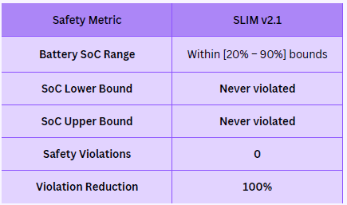
Scalability Analysis
As the number of agents in the network increases to 10, SLIM demonstrates a steady rise in performance, with the utility per agent increasing by approximately 11% (between -38.05 and -33.88) as the number of agents increases, a pointer to improved coordination and resource utilization with more agents. Conversely, grid-only systems grow inefficiently with scale, and utility decays under the influence of uncoordinated demand and increased penalties. In general, SLIM enjoys positive network effects, whereby an increase in the number of agents will facilitate increased trading opportunities, a higher degree of demand-supply matching, and enhanced system functionality.
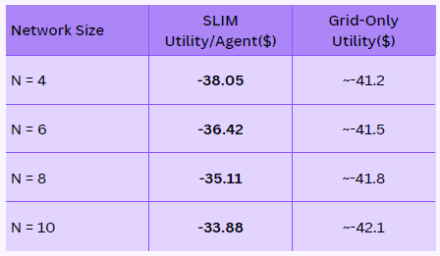
Energy market Dynamics
As the system scales from 4 to 10 agents, SLIM v2 demonstrates strong network benefits, with peer-to-peer (P2P) energy per agent increasing by ~48% and utility improving by ~12%, highlighting better outcomes through increased trading opportunities, while grid-only systems perform worse due to lack of coordination. The market is still competitive and efficient with prices standing at $0.10-0.20/kWh, more than 60 percent of daytime P2P load, and little activity at night because of low solar output. The system is also highly efficient and stable and has almost zero CO₂ penalties during sunny times, low battery degradation costs, and a moderate level of fairness among participants.
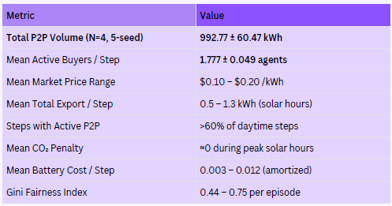
SLIM vs Existing Systems: Performance Comparison
SLIM significantly outperforms existing systems by enabling active and stable P2P energy trading, unlike grid-only systems, which have no P2P participation and rely entirely on the grid, leading to higher costs and inefficiency. Compared to legacy auction methods, which allow P2P but are unstable under changing solar conditions, SLIM achieves about 3× higher energy throughput (~892 kWh vs ~310 kWh) and reduces safety violations by around 15–19%. Overall, SLIM provides a better balance of efficiency, stability, and reliability.
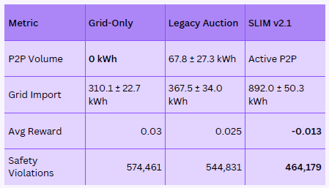
Conclusion and Future Work
The HELIOS Framework allows energy producers and consumers to trade energy securely and efficiently in a decentralized, peer-to-peer manner. This is made possible through a new consensus mechanism, termed ` "Golden Match," which has been developed specifically for decentralized energy systems. The mechanism is designed to reduce energy consumption compared to existing blockchain-based trading methods while maintaining security and reliability. Furthermore, the HELIOS Framework has been developed to support future compatibility with cryptocurrency-based payment systems and electric vehicle (EV) charging infrastructure. This would allow EVs to function not only as energy consumers but also as energy storage devices capable of participating in peer-to-peer energy trading. As a result, the The HELIOS framework represents an important step toward creating a self-sustaining, transparent, and democratized energy economy. The HELIOS framework is designed for iterative expansion. Future work will focus on three primary pillars to transition the prototype into a global production-grade ecosystem, namely the formal launch of the CHLORO token, a utility cryptocurrency designed to power the HELIOS ecosystem; connection to real-world smart meters through Advanced Metering Infrastructure (AMI); and utilization of more advanced predictive techniques, including deep learning models such as LSTM and Transformer networks.
The current chapter also introduced the Safety-constrained Liquidity-Integrated Market (SLIM), a multi-agent reinforcement learning framework designed for carbon-aware, decentralized peer-to-peer energy trading in residential microgrids, as the brain of HELIOS. The proposed framework addresses four key challenges that remain unresolved in existing approaches: enforcement of physical constraints, activation of cooperative market behavior, coordination among heterogeneous prosumers, and carbon-aware decision-making under realistic renewable variability.
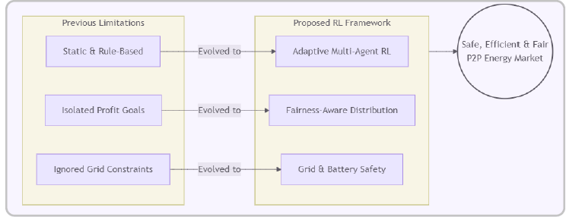
A central contribution of this work is the identification and mitigation of a Nash equilibrium collapse, a failure mode in cooperative multi-agent reinforcement learning where all agents converge to identical selling strategies. This behavior removes buyers from the market and results in zero peer-to-peer trading activity, irrespective of the market structure. To overcome this issue, three mechanisms are introduced: a bilateral P2P transaction incentive, a role-diversity penalty, and a market-balance state feature, all of which collectively restore active trading dynamics.
To ensure system safety, a two-tier architecture is proposed. The first layer is a deterministic three-stage projection mechanism that enforces hard physical constraints at every timestep. The second layer is a Lagrangian primal-dual optimization component that guides the learning process to avoid constraint violations proactively. This combination provides both strict safety guarantees and efficient policy learning.
The framework is evaluated using the real-world Ausgrid Solar Home Dataset across multiple independent runs. Results show substantial peer-to-peer trading activity, with consistent participation from buying agents, indicating successful elimination of the all-seller collapse. Importantly, no safety violations are observed during evaluation, demonstrating the effectiveness of the constraint-handling mechanism. Scalability analysis further reveals improved market liquidity as the number of agents increases. Additionally, the framework achieves notable reductions in carbon emissions compared to grid-only operation, validating the effectiveness of the carbon-aware reward formulation without requiring explicit environmental directives.
Despite these advancements, several limitations remain. The current implementation relies on a shared policy across all agents, which restricts the emergence of fully heterogeneous strategies. Although a ramp-rate constraint mechanism has been developed, it is not yet integrated into the primary evaluation pipeline. Furthermore, scalability to larger agent populations and validation across diverse regional datasets require further investigation.
Future work will focus on several directions. One key extension involves replacing the shared policy with independent learning approaches, such as individual PPO agents or value-decomposition methods like QMIX, to enable more diverse agent behaviors under the centralized training and decentralized execution paradigm. Another direction is the integration of a Graph Attention Network (GATv2) architecture to enhance coordination by capturing network topology and enabling interpretable inter-agent interactions in larger-scale energy systems.

